|  |
| --- |
| CSCI 6461 Computer Simulator |
| Design Notes |
| Author : Lulwah AlKulaib Amirah Abdulrahman Yichen Zhou Han Wang |
|  |
|  |

## **Project Overview**

The CISC Simulator is a project to build a basic Computer Simulator that demonstrates the structure of a computer system, the breakdown of ISA, executes instructions and operations.

## **Technology and Tools**

* Programming language: Java 1.8
* IDE: IntelliJ IDEA CE 2
* Repository: GitHub

## **Part I: Basic Machine**

### Description: We have implemented a simple memory that you can see represented in an Array. The Simulator has the ability to execute Load and Store instructions using the graphical user interface we have created.

### Input: Input file contains binary instructions.

### Test and Error handling: Exceptions and handlers are used when reading from file and elsewhere needed.

### API Maps: All labels on the left of Class Node are class properties; All labels on the right of Class Node are functions;

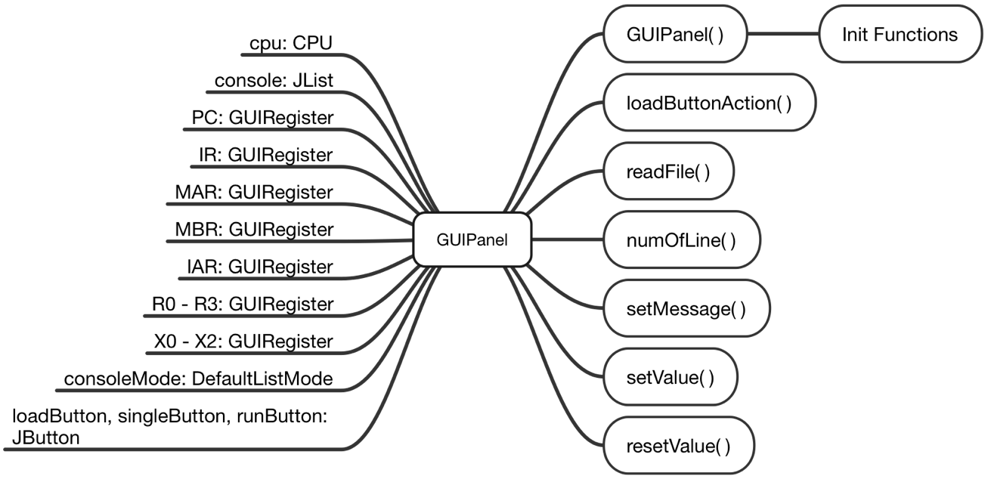

GUIPanel Class Node

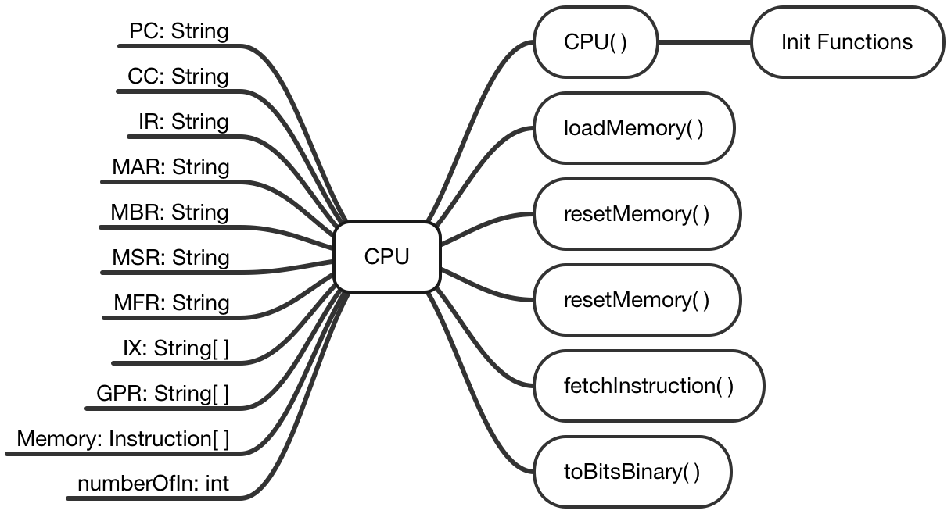

CPU Class Node

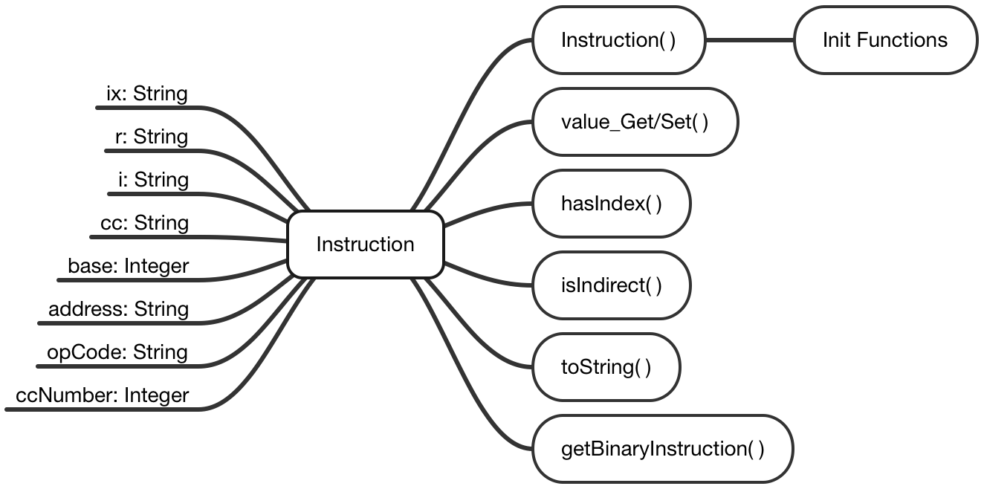

Instruction Class Node

### Classes Overview:

* 1. GUIPanel: Creates and initializes the Graphical User Interface, representing all objects in view, associated with their actions that are supposed to run when buttons are clicked.
  2. GUIRegister: Creates and initializes registers view.
  3. Instruction: A class where Instruction constructors are initialized, an Instruction can be broken down per it’s ISA, setters and getters available accordingly. Will be used more in upcoming phases.
  4. CPU: A class that performs ‘load’ instruction by loading file of binary instructions into memory, displaying the content on the GUI. It also holds the functionality of ‘Single Step’ instruction where a single line is read from memory, and registers values are changed accordingly on GUI.
  5. Main: Loads the GUIPanel and creates a new instance of it. The part that we run every time we run a new instance of the program.

**Part II: Memory and Cache Design**

**OpCodes**

In this phase, we have created the Opcodes to perform their correspondent tasks following the project description document.

|  |  |  |
| --- | --- | --- |
| OpCode | Name | Function |
| 0 | HLT | Halt Machine |
| 1 | LDR | Load Register from Memory |
| 2 | STR | Store Register to Memory |
| 3 | LDA | Load Accumulator with Memory |
| 4 | AMR | Add Memory to Register |
| 5 | SMR | Subtract Memory to Register |
| 6 | AIR | Add Immediate to Register |
| 7 | SIR | Subtract Immediate from Register |
| 10 | JZ | Jump if Zero |
| 11 | JNE | Jump if Not Equal |
| 12 | JCC | Jump if Conditional Code Specified |
| 13 | JMP | Unconditional Jump |
| 14 | JSR | Jump Subroutine |
| 15 | RFS | Return from Subroutine |
| 16 | SOB | Subtract One and Branch |
| 17 | JGE | Jump If Greater or Equal |
| 20 | MLT | Multiply Register by Register |
| 21 | DVD | Divide Register by Register |
| 22 | TRR | Test if the Contents of Two Registers are Equal |
| 23 | AND | Logical AND |
| 24 | ORR | Logical OR |
| 25 | NOT | Logical NOT |
| 30 | TRAP | Traps to Memory Address 0 |
| 31 | SRC | Shift Register by Count |
| 32 | RRC | Rotate Register by Count |
| 33 | FADD | Floating Add Memory to Register |
| 34 | FSUB | Floating Subtract from Register |
| 35 | VADD | Vector Add |
| 36 | VSUB | Vector Subtract |
| 37 | CNVRT | Convert to Fixed/Floating Point |
| 41 | LDX | Load Index Register from Memory |
| 42 | STX | Store Index Register to Memory |
| 50 | LDFR | Load Floating Register to Memory |
| 51 | STFR | Store Floating Register to Memory |
| 61 | IN | Input Character to Register |
| 62 | OUT | Output Character from Register |
| 63 | CHK | Check Device Status |

**Cache Design**

* We created a simple cache between the memory and the rest of the processor that uses a sort queue to store the addresses and the contents of data in memory.
* In each cycle, before searching the memory, we will first search for the address in cache.
* If we cannot find the address, we will then move the search to memory, and put a 16 bit word into cache.
* If the address is found in the cache, we will use the content stored in cache.

## **Part III: Execute All Instructions**

******Will come soon******

## **Part IV: A or B**

******Will come soon******

## **A. Floating Point and Vector Operations**

## **B: Enhanced Scheduling**

## **Version**

|  |  |  |  |
| --- | --- | --- | --- |
| Version No. | Version Date | Author | Description |
| 0.1 | 02-05-2017 | Han Wang, Lulwah AlKulaib | Phase I: Basic Machine |
| 0.2 | 03-04-2017 | Lulwah AlKulaib | Phase II: Memory and Cache Design |
|  |  |  |  |
|  |  |  |  |